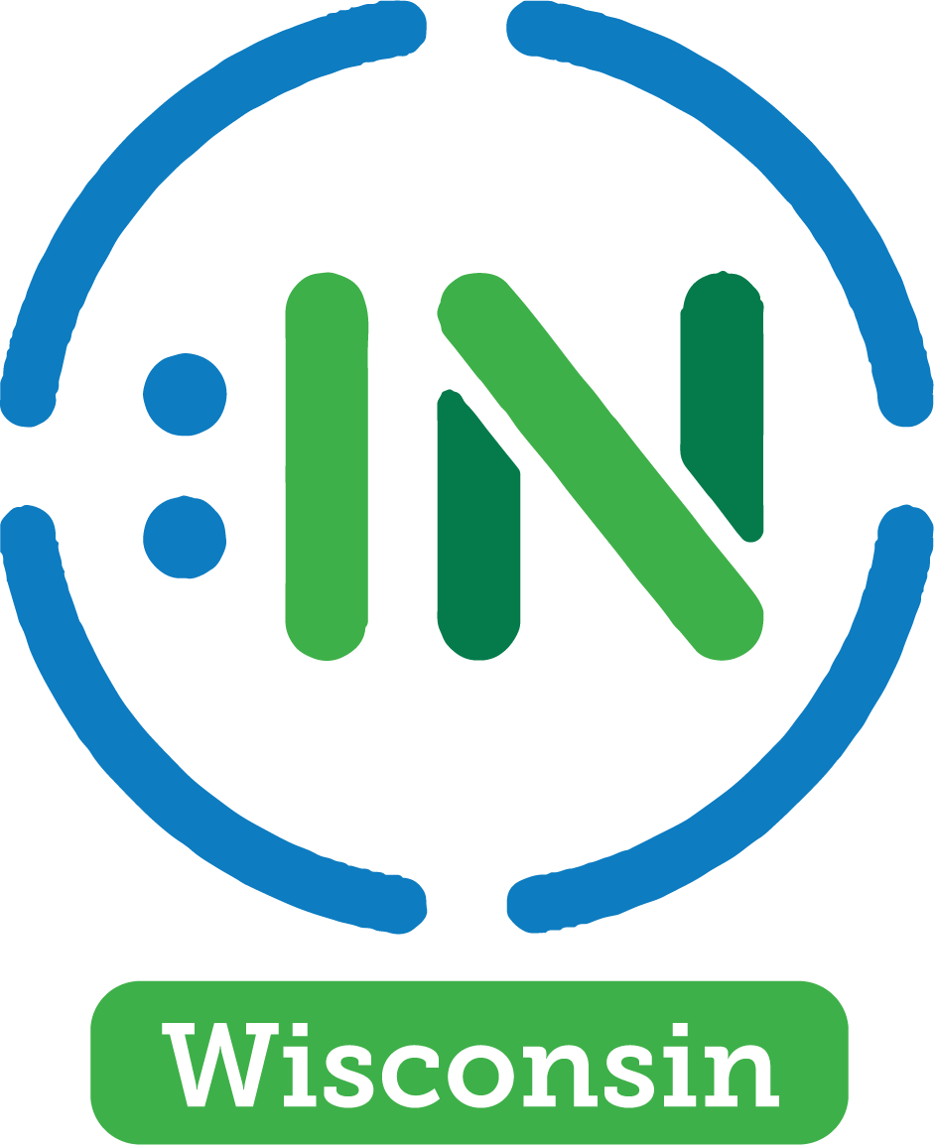

2023 IN Review

About Us
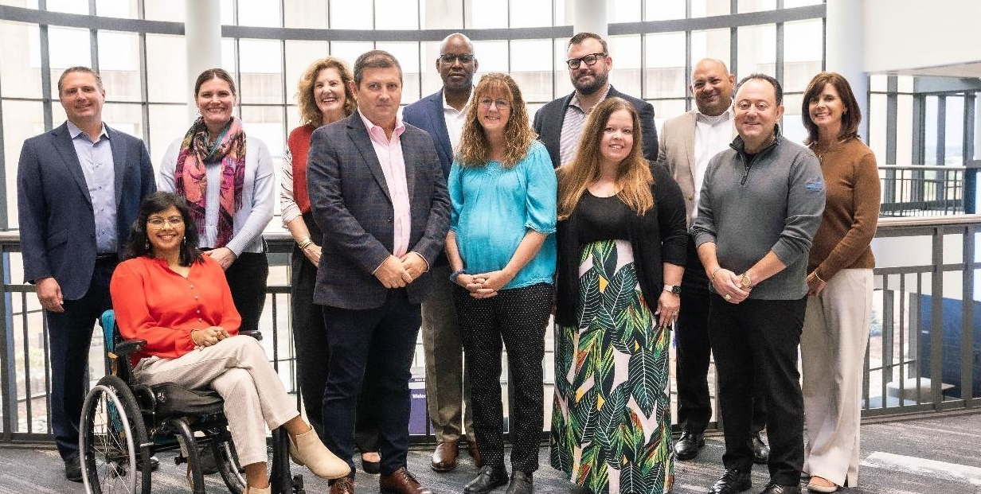
Disability:IN Wisconsin is a statewide business-led nonprofit organization focused on creating a more inclusive workplace for people with disabilities. Disability:IN Wisconsin promotes disability inclusion in the workplace, marketplace, and supply chain by working with member businesses to advance, improve, and expand employment outcomes for people with disabilities in Wisconsin.

Disability:IN Wisconsin is the state affiliate of Disability:IN, a leading nonprofit resource for business disability inclusion worldwide. Disability:IN and local affiliates raise a collective voice of positive change for people with disabilities
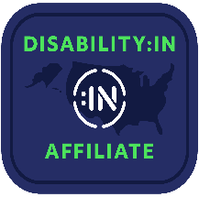

Our Vision
An inclusive global economy where people with disabilities participate fully and meaningfully.

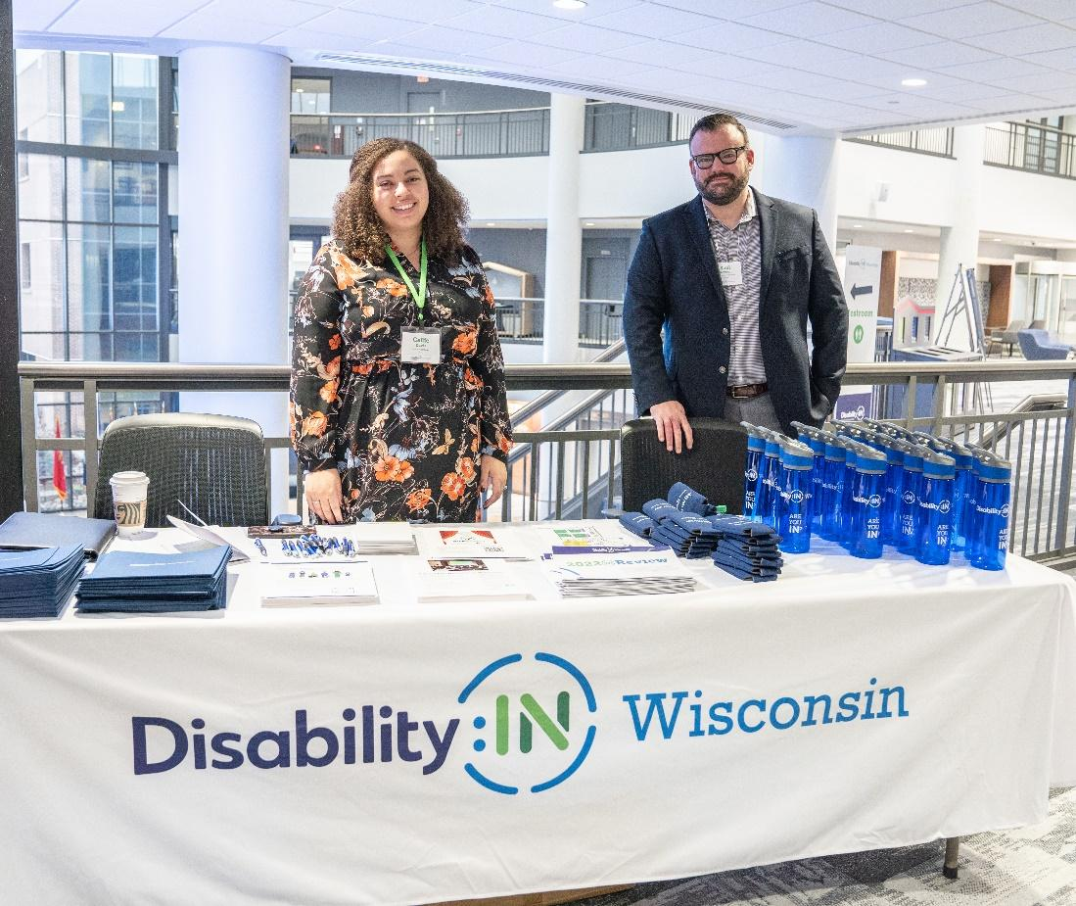
MEMBER ENGAGEMENT
COMMITTEE MEMBERS
Robyn Spiering Korn Ferry- Chair
Tracy Glorioso ManpowerGroup
Julie Effinger Trane Technologies
Tracey Andrus Rangam
Derek Smith AILCO
Faiza Strain WEC Energy Group

Our Mission
Disability:IN Wisconsin advances the cause of disability inclusion by creating awareness, advising corporations, and sharing proven strategies for including people with disabilities in the workplace, supply chain, and marketplace. We expand opportunities for people with disabilities by helping companies invigorate their disability initiatives, explore best practices, incorporate culture changes, and realize positive business outcomes.

Our Members

Charter Members
American Family Insurance | Associated Bank | Aurora Health Care | Fiserv | Froedtert & Medical College of Wisconsin | Genesis 10 | Kalahari Resorts & Conventions | Molson Coors | Old National Bank | Rangam Consultants, Inc. | TruStage | University of Wisconsin – Whitewater

Sustaining Members
Children’s Wisconsin | Franklin Energy | GE Healthcare | Johnson Financial Group | Kimberly-Clark | Kohl’s | ManpowerGroup | Northwestern Mutual | Oshkosh | Reinhart | Rockwell Automation | TeamSoft | The Marcus Corporation | US Bank | Trane Technologies | UW Credit Union | WEC Energy Group | WPS Health Solutions

Business Members
AILCO | Allis Tool & Machine Corp | Engauge | Islands of Brilliance | Product Accessibility LLC | SplitStar | Wallo Brands

Community Based/Non-Profit Members
AbleLight | Aspire | Best Buddies | Beyond Vision | Downtown Madison, Inc. | DSAW |
Easterseals | Employment Resources, Inc. | Good Friend, Inc. | Goodwill | IKE Center |
Milwaukee Center for Independence | Mind Shift | My Choice Wisconsin | The Ability Center | The Employability Project

From Our Executive Director

Greetings from Disability: IN Wisconsin! As the new Executive Director, it is my pleasure to share with you the significant progress and impact our organization has made over the past year in advancing the full inclusion of people with disabilities in the workforce.
As a business-led organization, Disability: IN Wisconsin is dedicated to fostering an inclusive workplace culture and ensuring equal employment opportunities for individuals with disabilities. We collaborate with businesses, government agencies, and community organizations to achieve this goal.
In the past year, we've made great strides toward our mission. Our membership has grown to include over 50 businesses and organizations, and we've lead the way in providing Wisconsin employers with valuable information and support. Through events, workshops, and partnerships in the public and private sectors, we have raised awareness about disability inclusion and advocated for the empowerment of individuals with disabilities in the workforce.
While we celebrate our achievements, we recognize that there's still much work to be done. We remain committed to our mission and will continue our efforts to create a more inclusive workplace culture in Wisconsin, ensuring equal employment opportunities for all.
Thank you for your unwavering support of Disability: IN Wisconsin. Together, we can make a lasting impact on the lives of individuals with disabilities and build a society where everyone has the opportunity to thrive and contribute.
Thank you for all you do,
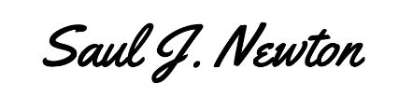
Saul J. Newton

Our Team
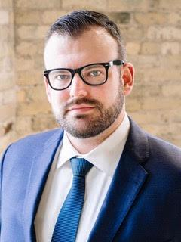 | 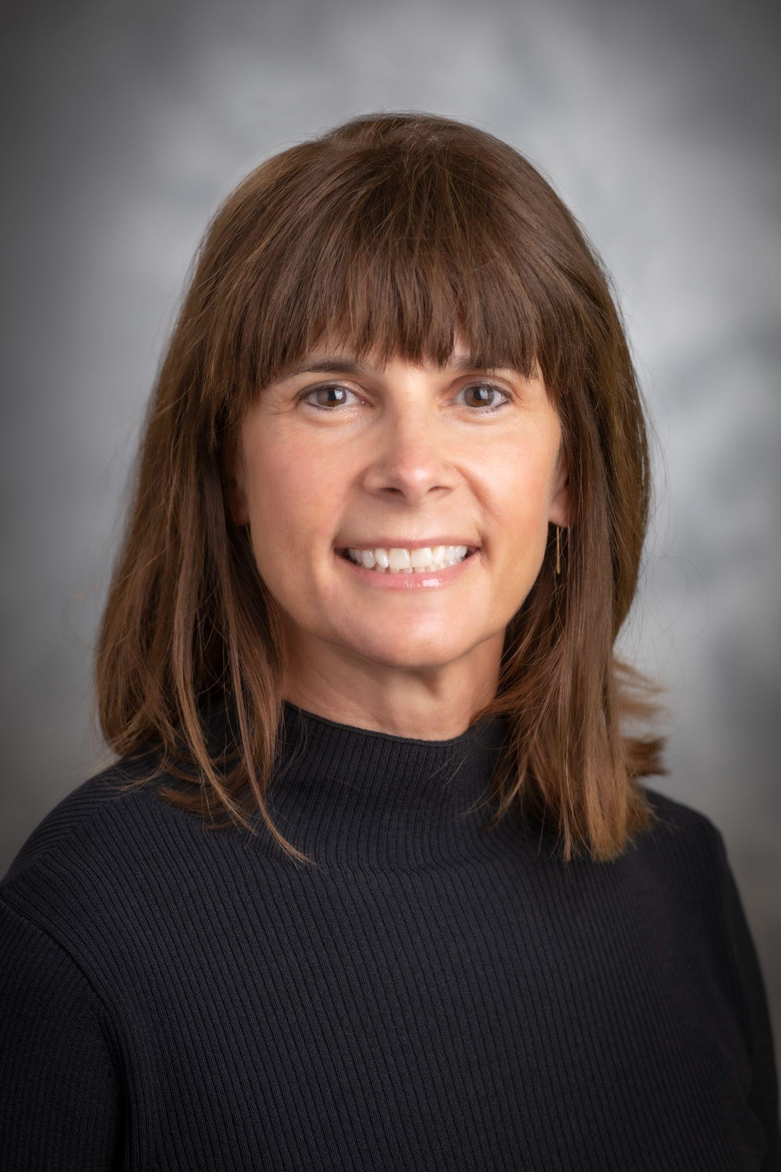
Saul Newton  Executive Director  Disability:IN Wisconsin | Martha Kendler  Communication Specialist  Product Accessibility LLC

Board of Directors, 2023

Tracy Glorioso, ManpowerGroup (Board Chair)
Tracey Andrus, Rangam Consulting (Vice Chair)
Juan Banda (Secretary)
David Bassett, Rockwell Automation (Treasurer)

Board Members, 2023
Victor Agapov, Wallo Brands
Troy Dennhof, Aurora Health Care
Julie Effinger, Trane Technologies
Dwayne Maddox, Old National Bank
Seetha Narayanaswamy, Northwestern Mutual
Tim Nau, TeamSoft
Cesar A. Pinzon Jr., American Family Insurance
Alyssa Ryanjoy, TruStage
Derek Smith, AILCO

A Year IN Review

53 Members Representing
Charter, Sustaining, Business, and Community Based/Non-Profit Members
Industries Represented
Financial Services
Manufacturing
Professional Services
Consumer Product/Entertainment
Healthcare Services/Hospitals
Social Services

Wisconsin Member organizations named ‘Best Place to Work for Disability Inclusion

Associated Bank | Fiserv, Froedtert & Medical College of Wisconsin | GE | Johnson Financial Group | ManpowerGroup | Old National Bank | Northwestern Mutual | US Bank |Trane Technologies |TruStage

National DOBE of the Year, 2023
Rangam Consultants, Inc

A Year IN Review

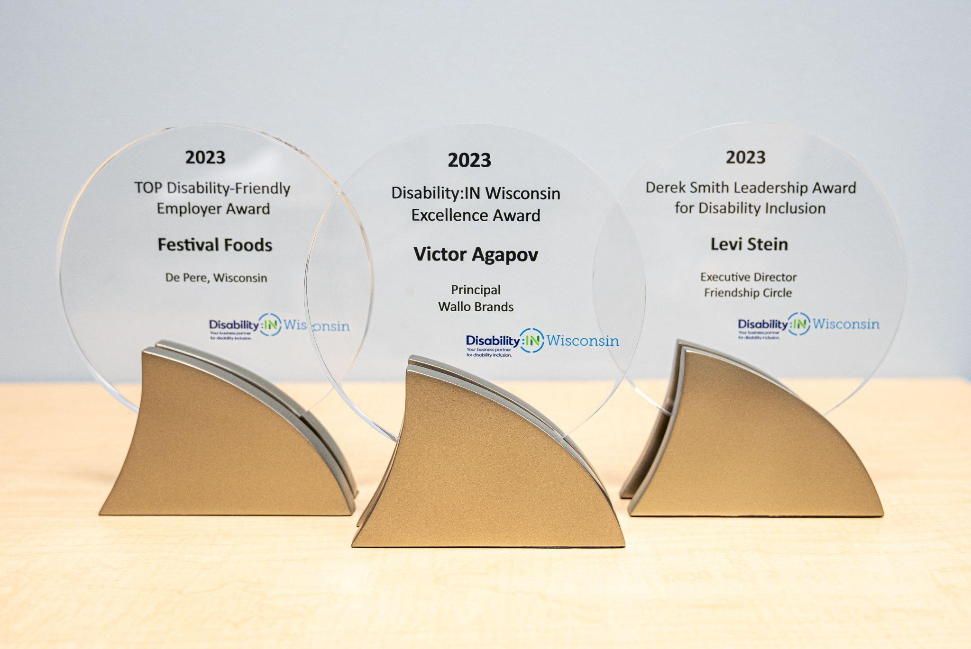
Derek Smith Leadership Award for Disability Inclusion
Levi Stein, Friendship Circle of Wisconsin
Top Disability-Friendly Employer in Wisconsin
Festival Food, De Pere, Wisconsin
Excellence Award
Victor Agapov, Wallo Brands

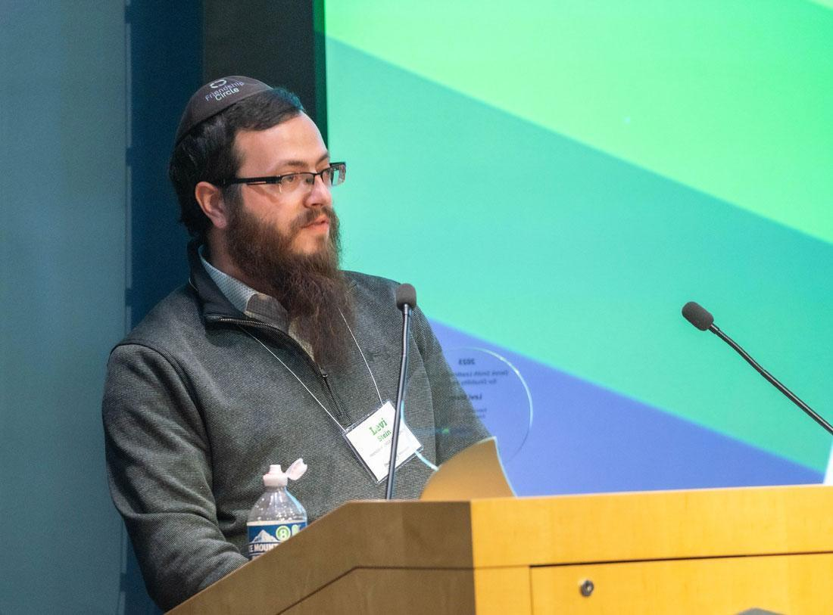
“What an honor to receive the Derek Smith Leadership Award for Disability Inclusion on behalf of The Friendship Circle… thank you to Disability:IN Wisconsin for putting together such an amazing Summit and for awarding us with this honor.”

Levi Stein, LinkedIN October 2023

2023 DISABILITY:IN WISCONSIN AFFILIATE AWARD WINNERS

2023 Experiences

Disability:IN Wisconsin Summit
The annual Disability:IN Wisconsin Ability Summit brings business professionals from around the state and beyond to share ideas and learn from each other. Dynamic and relevant speakers present on topics of workplace accessibility, disability employment and inclusion, and effective programs within their organizations.

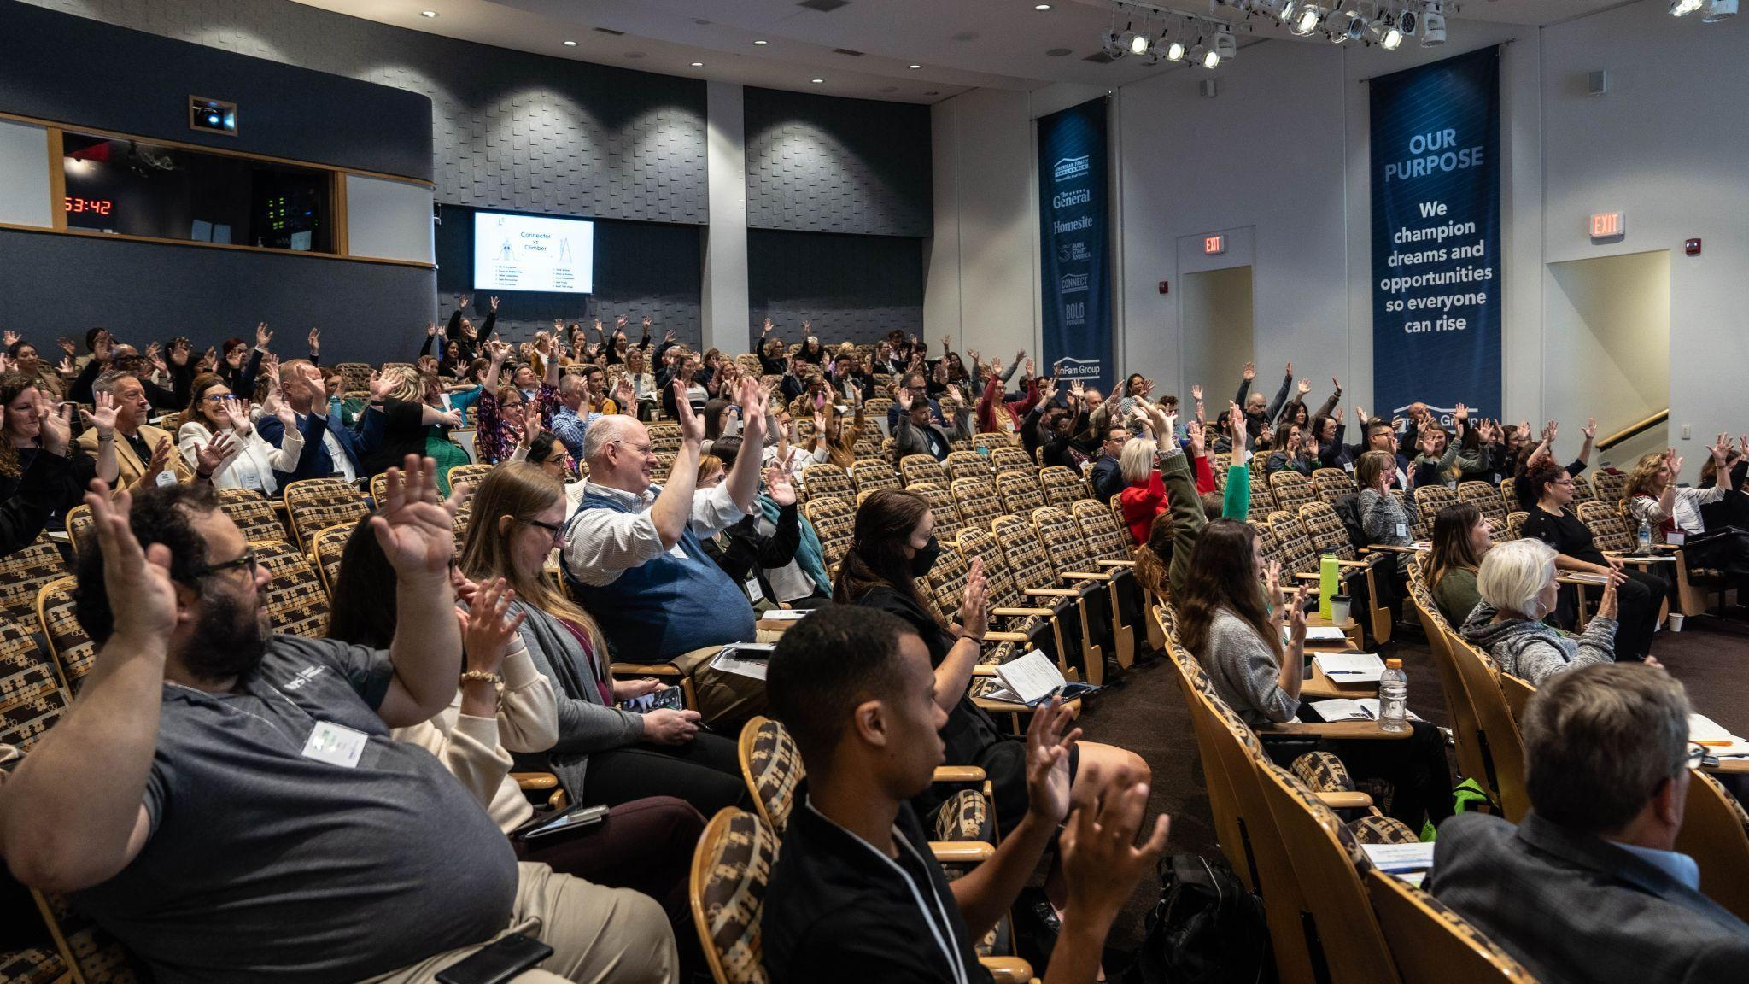
-Our 5th Anniversary for the Disability:IN Wisconsin Ability Summit
-Three Wisconsin leaders and businesses for their disability-inclusion impact.
-Over 200 registrants, twelve sponsors, and eighteen partners and speakers

Hosted by American Family Insurance and Sponsored by
CHAMPION: TruStage, MolsonCoors, Aurora Health Care, ManpowerGroup, Kohls
ADVOCATE: Trane, Franklin Energy, UWHealth
SUPPORTER: WPS Health Solutions, UW Credit Union, Rangam Consultants, Rockwell Automation

Film Premier, Neurodiversity at Work
Aligning with our mission of disability employment, Disability:IN Wisconsin collaborated on the film, Neurodiversity at Work, with Good Friend, Inc. who has created a number of award-winning videos and are focused in the area of autism and neurodiversity.

The scope of this collaboration was a documentary film featuring the experiences of 10 successfully employed neurodivergent individuals. Several individuals work at member businesses. The Premier was a wonderful night in Milwaukee, with over 230 attendees, representing 42 businesses in and around Wisconsin.

Hosted by The Pfister Hotel and Sponsored by
The Marcus Corporation, Rockwell Automation

This project is being supported, in whole or in part, by federal award number SLFRP0135 awarded to the Down Syndrome Association of Wisconsin via the Wisconsin Department of Administration by the U.S. Department of the Treasury

2023 Experiences

PROGRAM COMMITTEE MEMBERS
Chair: Mary Dess, Karie Berkley, Grace LoCoco and their team of volunteers.
- We held 9 Educational Events focused on ‘Building A Framework for Disability Inclusion’
- We distributed a valued, monthly Newsletter with an average readership of 40%.
- Members engaged this year through in-person and on-line event with a total 988 attendees (+35% vs. 2022)
- 46 Event Partners

ERG/BRG NETWORKING COMMITTEE
Co-Chairs Kelly Risser, Seetha Narayanaswamy, Jason Sprunk, Jackie Steffenhagen and their team of volunteers. We developed two In-Person Events:
- For Prospective New Members: Greet Then Meet Networking for Prospective New Members (Madison, WI)
- For Manufacturing Businesses: Hiring Neurodiverse Employees to Grow Manufacturing Production.

DISABILITY IN WISCONSIN GOLF OUTING,
hosted by Rockwell Automation and Disability:IN Wisconsin, Sponsors:
American Family Insurance, Bay Marine, BW Converting Solutions, CAI, Faith Technologies, Revere Electric, Rockwell Automation, Russ Darrow, Shumway Dental, Vistex, Werner Electric
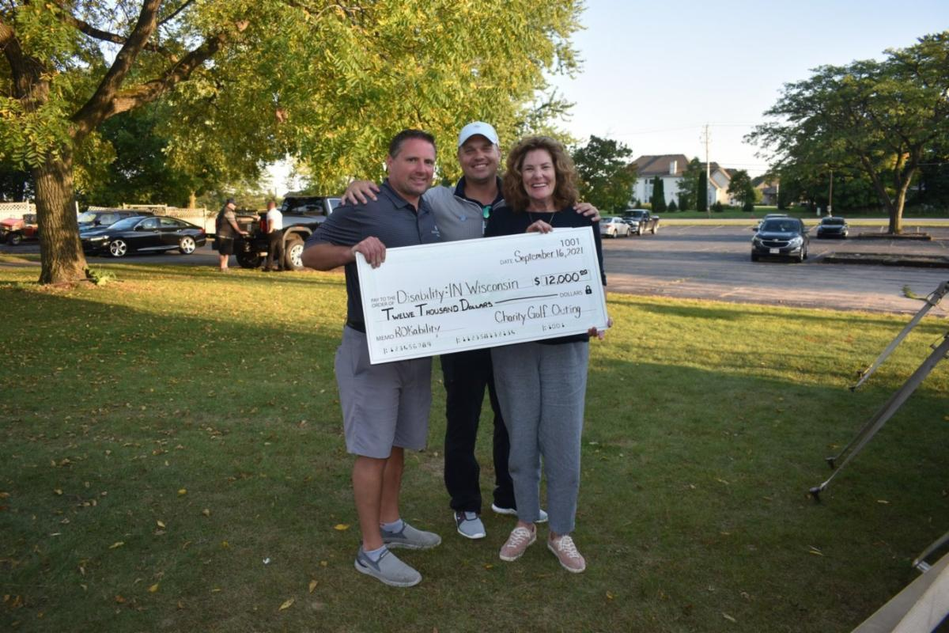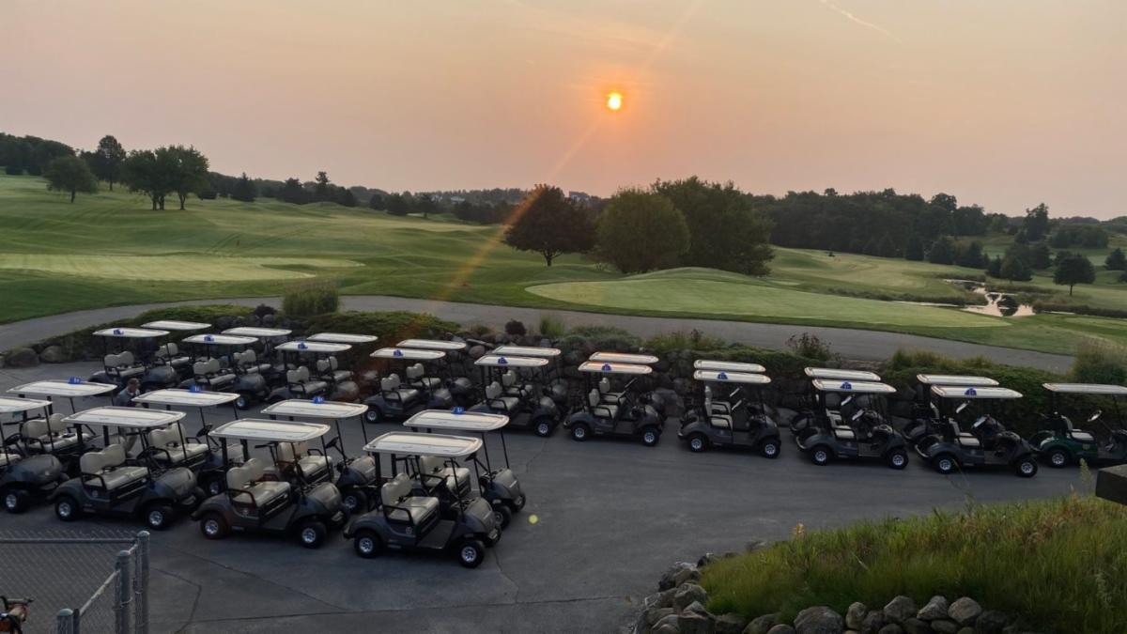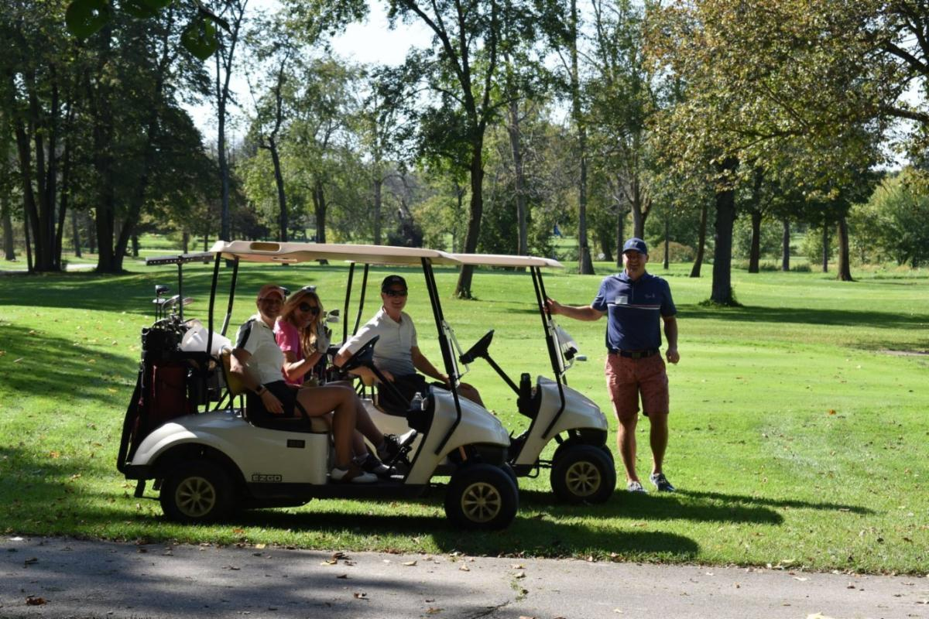

Members Are IN

Phone Number
(414) 316-1163

Email Address
info@disabilityinwisconsin.org

Website
disabilityinwisconsin.org

LinkedIN
https://www.linkedin.com/company/disability-in-wi

Instagram
@disabilityinwisconsin

