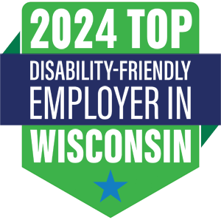
In recognition of businesses championing transformative cultural shifts to foster an inclusive workplace for individuals with disabilities, Disability:IN Wisconsin takes great pride in announcing the 2nd Annual Top Disability-Friendly Employer in Wisconsin Award™. This prestigious accolade is dedicated to honoring companies committed to advancing disability inclusion and equity within their workforce.

Celebrate the Impact of Your Business:

- Share your innovative strategies for enhancing employment opportunities for individuals with disabilities.
- Acknowledge and celebrate the hard work and dedication of employees who have played a pivotal role in your company's success.
- Spotlight your proactive measures in recruiting, hiring, retaining, and advancing qualified individuals with disabilities.
- Align with other esteemed organizations dedicated to achieving disability inclusion and equity.
- Showcase industry-first initiatives and noteworthy accomplishments that set your business apart.

Nominations must be submitted by July 20, 2024.

Mark your calendars for Thursday, October 3, when the prestigious award will be presented at the 2023 Disability:IN Wisconsin Summit, followed by a reception to honor the award winner and their company.

Who Can Apply

- The program welcomes participation from any business in Wisconsin committed to advancing disability inclusion in the workplace.
- Nominations should be submitted by or on behalf of the company's headquarters, focusing on the achievements, policies, and practices of the overall company, not individual branches or units.
- Companies have the flexibility to either self-nominate or be nominated by another company.
- Nominations are exclusively accepted through the official online form within the specified timeframe.

“We can succeed in making progress if we work together. To make progress in disability inclusion, companies must treat it as a business priority with goals, plans, measurements, and accountability. In connecting business leaders to best practices and each other, we strive to advance disability inclusion and equality.” Judy Quigley, Executive Director

Do you have an employer in mind worthy of a nomination?

